Musica Viva Concert:
The first of two concerts will be held at Bowen PS Hall on Wednesday 1st June at 10:00am.
Due to the starting time parents are asked to drop their children at Bowen (not before 9:45am) and then Cooks Bus will bring the children back to school.
Winter uniform is to be worn (pinafores and long white socks for girls) by all children. The cost is $6.00 per child.
A payment slip is attached. Please return to the school office by Friday 27th May.
Parents are welcome free of charge.

Tennis Lessons:
Too many children are forgetting their sneakers and money for lessons. As this is an extra-curricular activity those without their money and correct footwear will be unable to participate. To avoid forgetting their sneakers children may wear them to school on Monday.

School Speck Concert:
Please complete an Expression of Interest for students to perform in the Orange Regional Conservatorium’s School Speck Concert on Tuesday 14th June @ 6:30pm.
Spring Terrace’s participation will depend on the number of students who are able to attend this mid week.
This year the venue is the Orange Function Centre.

Scarecrow Competition
Orange Show
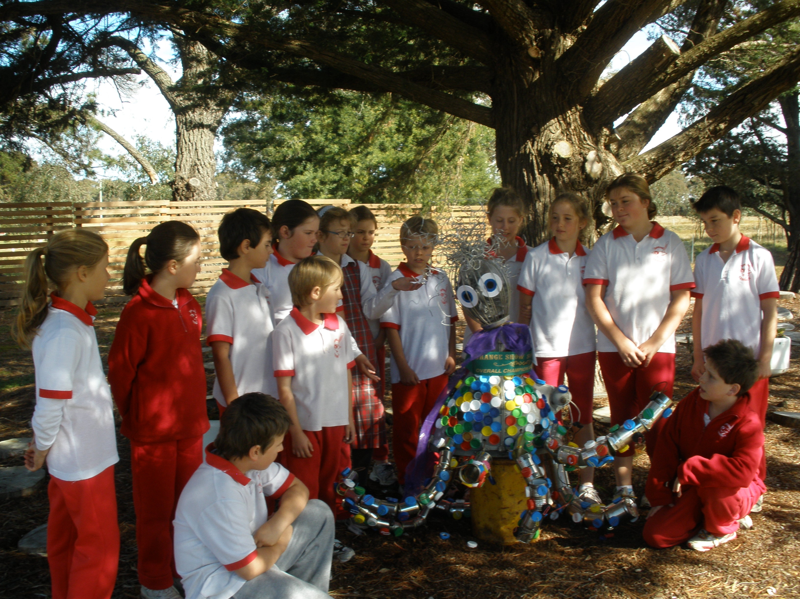

Congratulations to our artistic creator and everyone who
assisted with the Octopus Scarecrow. It won the Grand
Champion Prize.
For those who missed seeing it, it will be on display in the
Environmental Area replacing the previous creation.

Small Schools 2010 Instrumental Invoices:
These are attached for those concerned. This is the final reminder. If fees remain outstanding, it may impact on individual students’ continued participation in the program.

Junior and Senior Dance Ensembles:
Individual students who tried out and were selected to participate will receive ongoing information re rehearsals, venues and times.
Please read notes carefully as the content is subject to last minute changes.

Library Matters:
A timely reminder to all – LIBRARY BAGS ARE TO BE CARRIED SEPARATELY – and not in school bags.
This is to avoid accidental damage to library books from leaking drink bottles/food stains, etc.
Also books damaged repair or lost will be invoiced for replacement.

Premier’s Reading Challenge:
Congratulations to Lauren, Harry and Skye C for completing the Challenge.

Parent Lunch
Lis has organised a Parent Lunch next Tuesday 24th May at 1:00pm. Please bring a Plate.
The address is 1247 Forest Road. All Welcome.

The Parenting Ideas Magazine:
As the school subscribes to Michael Grose website, the magazine for parents is now available at –www.parentingideas.com.au

Dates - CWA International Day
Millthorpe Bowling Club
Thursday 23rd June 11:30am-1:00pm

District Cross Country Cudal
Friday 27th May

Urgent Reminder:
ALL Report (black) Folders and Art Folios need to be returned to school early next week.

Jenny/Val/Marilyn/Marie/Hannah/Alison/Lester

