Musica Viva:
Children have really enjoyed the performance on Wednesday at Bowen. One comment “awesome”.
Thank you to Mrs Lynch for co-ordinating this event each year for OSSA.

Staff Matters
Thank you to all the Relieving Staff who have filled in at short notice covering staff accident and illness. This has been a difficult week for the Office as it is rare for this amount of absenteeism.

Student Illness
Most families have been affected by illness of students in the last couple of weeks. As advised in this week's CWD anyone who is unwell needs to stay at home to minimise the spread of infection to others.

CWA Country of Study
The children have been working on flags, colouring in, posters, projects and travel brochures. These will be collected on Thursday 9th June. Parents who intend to be at Millthorpe Bowling Club on Thursday 23rd June are asked to notify the office of their intention and numbers by Wednesday
8th June. This information is passed on to the CWA ladies to assist with catering arrangements.

School Speck – Tuesday 14th June OFC :
Mrs Riles has forwarded further important information which is attached.
Mrs Riles has been preparing Yrs 3-6 students as part of the Small Schools Combined Choir.
Please return completed ORC permission note to the school office by Friday 10th June.

Report Folders/Scrapbooks
Please return these ASAP. New students will be given a Folder but parents need to purchase a Scrapbook for student work samples.

Tennis:
Please, students need to wear/bring their sneakers and $6.00 to school each Monday for lessons.

New Principal:
It has been confirmed that Mr Peter Scott will be starting here first day of Term 3 and that he is to visit the school towards the end of this term. Parents will be further advised of details for this visit.

Snap of the Week – Principal on Duty

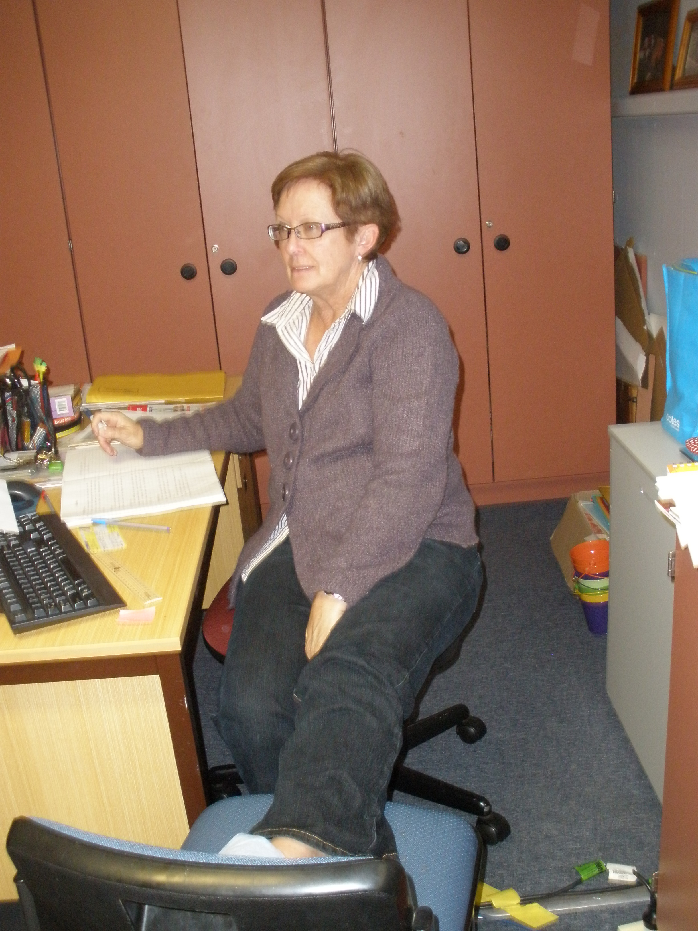

Jenny/Val/Marilyn/Marie/Hannah/Alison/Lester

