◘◘◘◘◘ ◘◘◘◘◘
What’s on!
Term 4:

- Assembly: this Thursday 14 Dec at 2.45pm
- Last Day of Term: this Friday 15 Dec
- First Day of School 2018: Tuesday 30 January

Rlg Principal Final Comment

How quickly does a term go when you’re busy and you’re having fun! Well, here we are… the last week of the year! Both classes are well past assessments and teachers have been working hard formulating reports, using assessment tasks and regular day-to-day class activity to obtain a clear picture of your child’s skills and abilities. Furthermore, the reports are a reflection of your child’s growth throughout the semester and where they are in respect to their learning, at this point in time. Teachers will be available throughout the remainder of the week to explain the reports in greater detail, if you are concerned about any element of your child’s report.

I’ve said this once before and probably not my last – thank you to the Spring Terrace Public School Community for making my brief stay at your lovely school a warm and caring experience. I’ve thoroughly enjoyed the role of Rlg Principal, but it’s time to head back to the hustle and bustle of Calare Public School.

Have a lovely time catching up with family and friends over the holiday period, rest, re-energise, stay safe and get ready for an even bigger year in 2018.

Take care,

Darren Keed.

The End of Another Great Year

We have come to the end of another fun filled and productive year at Spring Terrace School. The staff have once again excelled in providing lots of great opportunities for our students.

Thank you to Mr Keed for leaving relieving as principal and teaching the primary class, I know the students staff and community have enjoyed having him in our school.

Thank you to Mrs Barrett, not only for her work this year in the classroom but for all of the great things she has done over the last four years at Spring Terrace. I know she will be missed by the students, staff and community. I'm sure she will find her time teaching at Orange Public rewarding.

Thank you also to Mrs PE for all her hard work over the past 10 years at Spring Terrace, while Mrs PE is retiring from teaching it will be great to have her back as a volunteer in 2018.

I'm looking forward to working with Mrs Pulling, Miss Paige, Mrs Chapman and Mr Davis along with the community in ensuring that we continue to provide a great environment and education for students of Spring Terrace Public School. I'm also looking forward to working with Mrs Colquhoun who I know brings with her a range of great teaching ideas and skills.

I'd like to wish all of our students and their families a safe and happy holiday and look forward to returning next year.

Mr Peter Scott

Principal

School Bus Coming

Last Friday, we were given the news that Apple City Tours have been given the interim contract for our bus service to start in 2018. It will be important that the bus service is well used, if it is not, Transport NSW could still decide that it is not required.

The bus’s first stop will be in North Orange on Burrendong Way at approximately 8am, then at the Civic Theatre and Brabham Park. It will then pick up students on Cadia Rd, Forest Reefs Rd and finally proceed to school along Spring Terrace Rd.
The route has been worked out on our 2017 enrolments as per Transport NSW instructions but once the 2018 enrolments are taken into consideration there may be some changes to the route and stops.

Tomorrow Apple City Tours will bring one of their buses to school at 9:15 am. This will be an opportunity for students and staff to have a look at the bus and go for a ride. Julie Marshall, from Apple City Tours, who has worked to ensure that everything is ready to go for day one in 2018, will be here to answer any questions.
We will hold a meeting with parents on Monday the 29th of January 2018, the day before students return to school next year, to talk about the route, bus safety and the expectations of students. She will also discuss how they can be contacted, if for example your child misses the bus or needs to do something other than get off at their regular stop.
Central Western Daily will have a photographer in attendance tomorrow to take photos for, and possibly talk to a couple of students.

Last Day of School

This Friday the 15th of December is the last day of school for this year. Students are allowed to wear casual clothes that are sensible, that is a shirt/top/dress with sleeves (to prevent sunburn) and covered in shoes.

The School P & C will be providing a “Hot Dog” lunch for all the students. The students should have already let Shirley know their order.
There will be no canteen orders for lunch this Friday due to the ‘Hot Dog Day’ however orders will be taken for Friday recess if the students wish to order a fruit cup or cake.
Students return to school next year on Tuesday the 30th January, 2018.

Presentation Evening

The Presentation evening on Thursday went well. The students entertained their families and friends with musical prowess of singing, percussion instrument playing and ukelele strumming.
The evening was concluded with a shared supper and a surprise visit from the big man in the red suit on the back of his rusty holden ute. It was great to see Santa doing what he does so well - the act of giving.

Assembly

Please join us for an assembly this Thursday the 14th of December at 2.45pm.

Farewell for Narelle and Marilyn

A reminder that a farewell dinner and drinks will held for Narelle and Marilyn this coming Saturday, from 6.45pm, at the Hotel Canobolas in Orange. Please RSVP to Renee Smith on 0421 497 400 by tomorrow, if you haven’t already done so.

Term in Review

A few snaps of the term in review. Do you remember these?

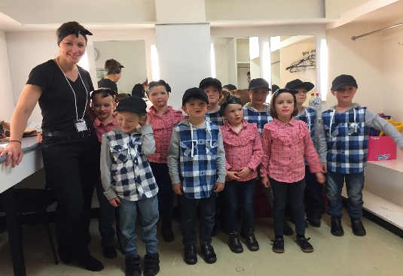

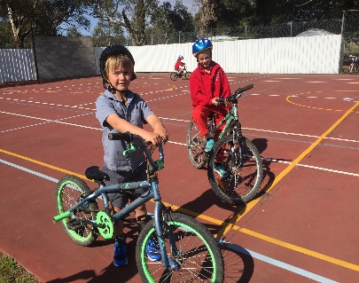

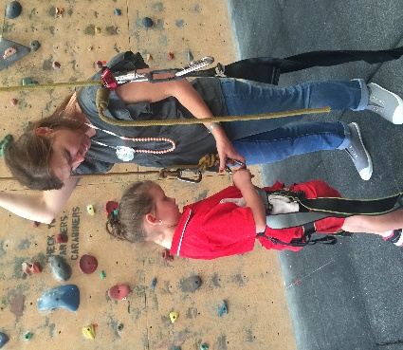

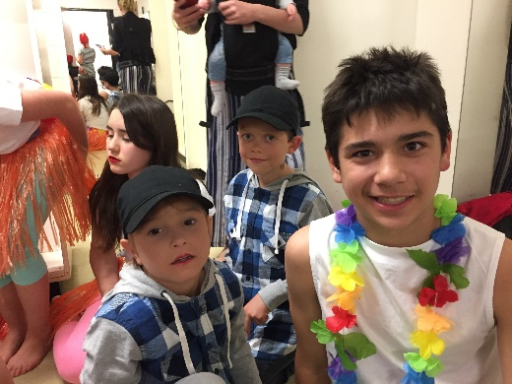

Spring Into School

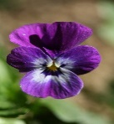
- Spring into School resumes on Tuesday the 30^{th of} January, 2018.

