◘◘◘◘◘ ◘◘◘◘◘
What’s on!
Term 4

- ASSEMBLY: 30 November
- SPRING INTO SCHOOL: 5th December
- P&C AGM: 6th December
- PRESENTATION NIGHT: 7th December
- INFANTS TABLOIDS: 11th December

Pizza Day
A reminder to have your note in tomorrow for the pizza day on Wednesday 29th. Mrs P.E. is the organising teacher. You won’t need lunch on that day!

End Of Year Excursion
This Friday 1st December, 2017 is our Major Excursion day. Please see Mr Keed, if you have any questions or would like to discuss anything.

Our itinerary is set out as follows:
Depart for Canberra: 6.00am
Arrive in Canberra: 9.45 – 10.00am
Morning Tea: 10.00am
Dinosaur Museum: 10.00 – 11.00am
Rock Climbing: 12.00 to 1.30pm
Lunch: 1.45pm
The Mint: 2.00 – 3.00pm
Afternoon Tea: 3.00 – 3.30pm
Dep from Canberra: 4.00pm
Return to our school: App 8.00pm

PLEASE RETURN YOUR PERMISSION NOTE AND MONEY BY TOMORROW, WEDNESDAY 29TH NOVEMBER IF YOU HAVEN’T DONE SO
THANK YOU

Presentation Night
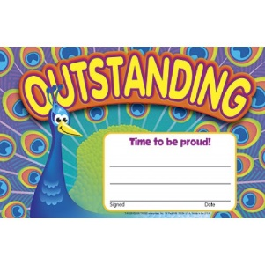
Our annual Presentation Night is fast approaching and is organised for Thursday, 7th December. Information regarding the evening will be sent out early next week. The event will be held on the school grounds, weather permitting. We’d love to see as many parents and students as possible on the night to celebrate and reward all your children’s hard work throughout the year.

Jack May Cup
Swimming Carnival
Spring Hill and Spring Terrace came together on Friday, 24th November to hold the last leg of the Jack May Cup. It was great to see so many children from both schools turn up and participate – participation is what makes a carnival fun. A huge thank you to Mrs McAnulty and her staff for their assistance to ensure the day went off without minimal fuss!!
Also, a huge thank you to Mrs Barrett for coordinating the non-swimming activities throughout the day.

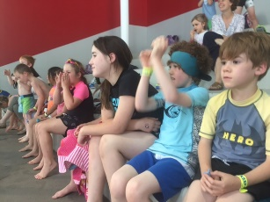
This gave many of our kids an opportunity to develop their confidence and skills in the pool in a fun and exciting way! See you in 2018 Jack May!

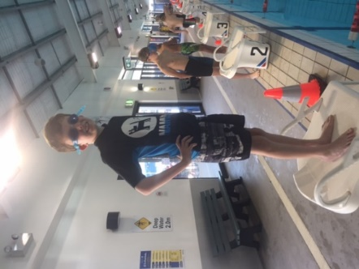

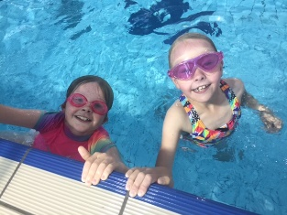
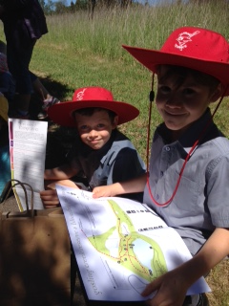

Gosling Creek Birdwatching
On Tuesday last week the Infants class and the Spring into School program went to Gosling Creek Reserve to do birdwatching as a culmination of our units in Science on birds and their habitats. We had a wonderful day and sighted 13 different species. The children followed a map of the Reserve and sketched a bird they sighted on the trip.
We ended the morning with a play on the equipment. It was a wonderful shared event to do with the younger students of our school. Thank you to Shirley Blandford for transporting us to and from Gosling Creek safely in the mini bus.

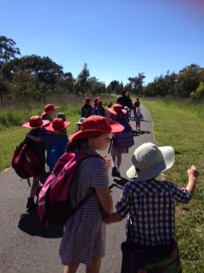

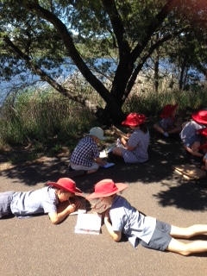

Spring Into School

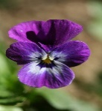
- Our NEXT session is 5th December 2017

- Term 3 invoicing – please make arrangements to pay for Term 3, if you havent already done so.

----------------------------------------------------------------

P&C News
The next meeting for the P&C will be held next week on the 6th December, which is our AGM. Hoping to see as many community members there.

◊◊◊ COMMUNITY NEWS ◊◊◊

Skate Boarding Event At Millthorpe –
3RD December 2017

Young people of Millthorpe and surrounds are welcome to come and try skateboarding no matter what their skills or just watch. A free event will be held on Sunday, 3rd December from 9:30am to 1:30pm at the Millthorpe Skate Park on Boomerang Road. Skateboards and helmets supplied, but you can byo. To take part, you must register online at http://www.totemskateboarding.com/ or just before the event with the participants’ guardian signing an insurance waiver. For more info, contact Darrin Yates on 6362 6623, 0411 789 062 or email darrin.yates@sport.nsw.gov.au.

