|  |  |  |
| --- | --- | --- |
| Spring Terrace Newsletter  Spring Terrace Public School  A Community of Confident Learners  573 Forest Road, Spring Terrace NSW 2798 T: 02 63654287 Email: springterr-p.school@det.nsw.edu.au | | |
| 150 | | |
| Term 3 | Week 1 | **Tuesday 23rd July 2019** |
| Celebrating  Years 1869-2019 | | |

|  |
| --- |
| What’s on!!  2019  **Monday 29th July-Thursday 1st Aug** – Interviews  **Wednesday 7th Aug -** Education Week Activities  **Monday 12th Aug –** School Photos  **Thursday 29th Aug –** Orange Eisteddfod |
| Canteen this Week: Grossmith Family |

# Welcome back!

Welcome to what is going to be a very busy and productive term at Spring Terrace. Some of the coming events include Education Week, Book Week and our 150 years celebration. This term we will also be getting ready for the OSSA Spectacular which takes place early in Term 4.

In the classrooms this term we will be following up on our Super Heroes we introduced in Term 2 and will be introducing the Bounce Back Program. Bounce Back will complement our Super Heroes and the work we do on student well-being.

Amongst all of this we are looking forward to seeing our students continue to set goals, be great learners and make stunning progress.

# 3-Way Interviews

Interviews with students, parents and teachers will take place next week between Monday 29th July and Thursday 1st August. Please indicate a time slot on the attached note and return by Thursday so that specific interview times can be sent home.

# School Photos

School Photos will be taken on Monday 12th August at 9:30am. Students need to be in the school winter dress uniform. This includes tartan tunic, pants or skirt for girls and grey button up shirt and pants for boys. All students need to wear black shoes.

**Touch Football**

Tomorrow Zakk, Riley and Chelsea will play touch football for OSSA White against OSSA Green in the PSSA State Knockout. Mr Scott is coaching this team.

**Prac Teacher**

Tomorrow we will welcome Miss Kinesha Roweth, a prac student from Charles Sturt University. Miss Roweth will be in the primary class each Wednesday for the next 8 weeks.

**OSSA Spectacular Dance Practise**

This Thursday we will begin practising our dances for the OSSA Spectacular which will take place in Term 4. Each Thursday this term a dance teacher from Fuse Dance in Orange will teach each of the classes their dance.

**School Beautification**

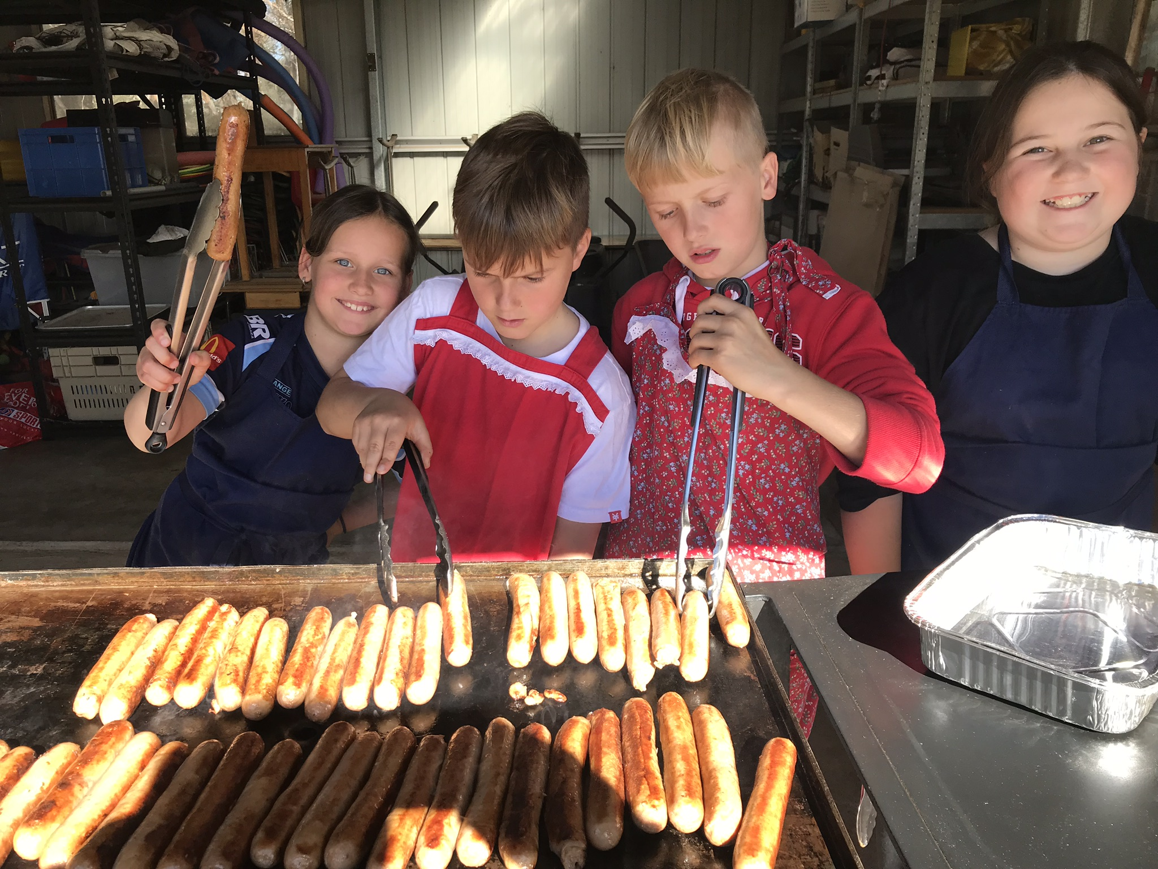

A group of interested parents and community members met during the holidays to make plans to brighten up the front of the school. They’ve got some great ideas and are ready to get started. It’s not too late to get involved if you like gardening, painting or landscaping. If you’re interested please speak to a P&C committee member or Mr Scott.

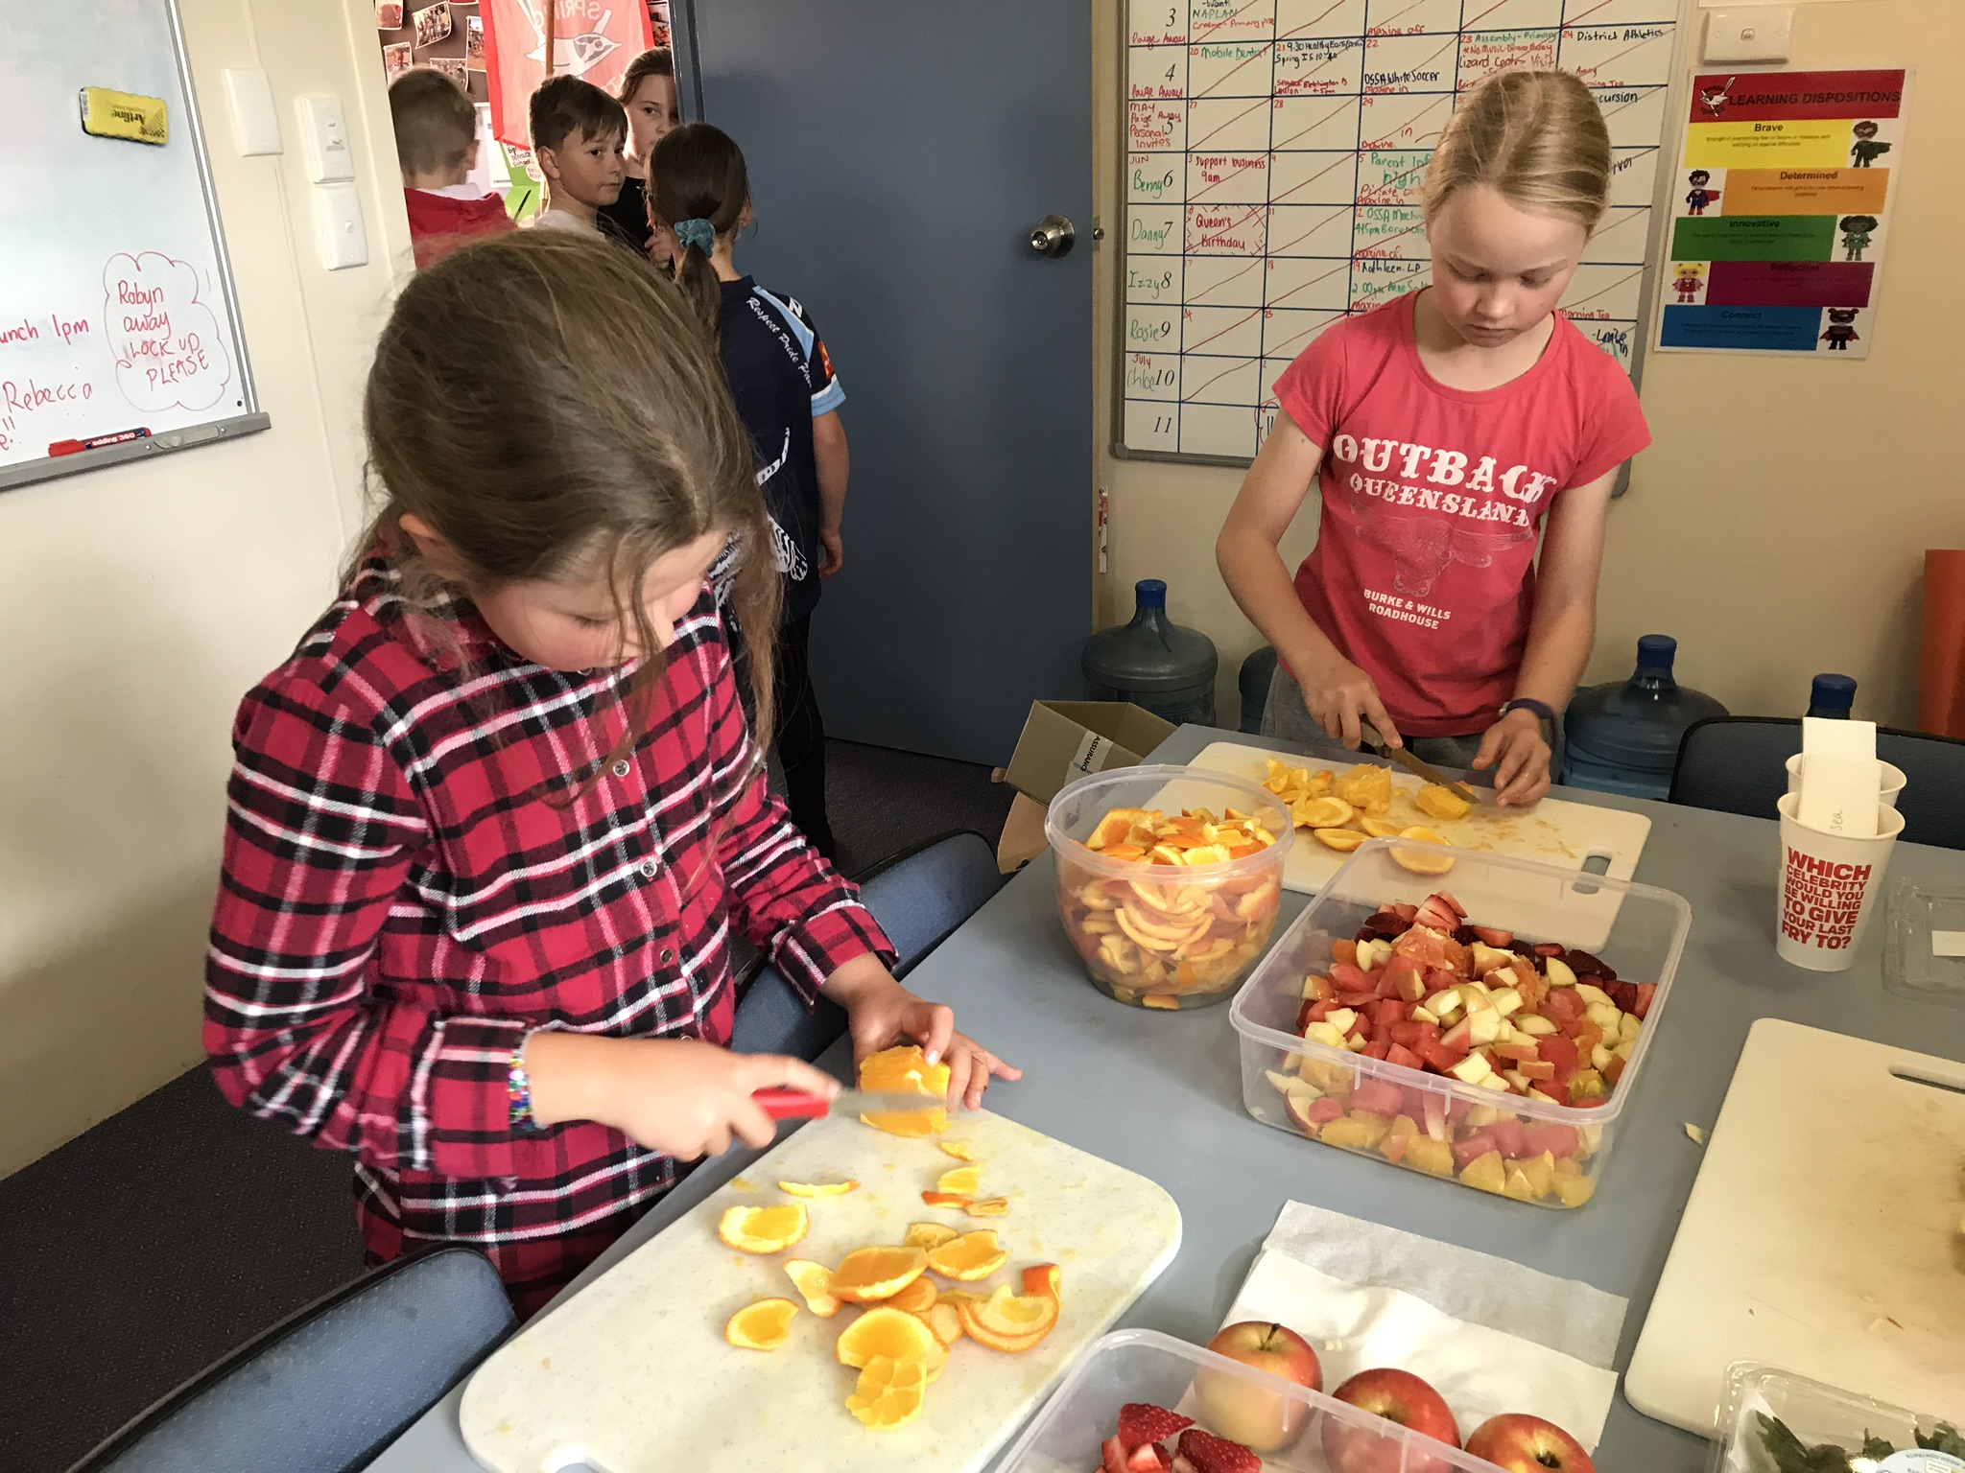

**Orange Eisteddfod**

The whole school is performing in the Orange Eisteddfod which is on Thursday 29th August at the Orange Function centre.

# Seesaw

Don’t forget to sign up to Seesaw. If you’d rather use a computer than a smart phone to see what your child and their teacher are sharing, the log on details are on the same sheet as the QR Code.

# Spring Into School

Please ensure your children have a change of clothes in case of accidents.

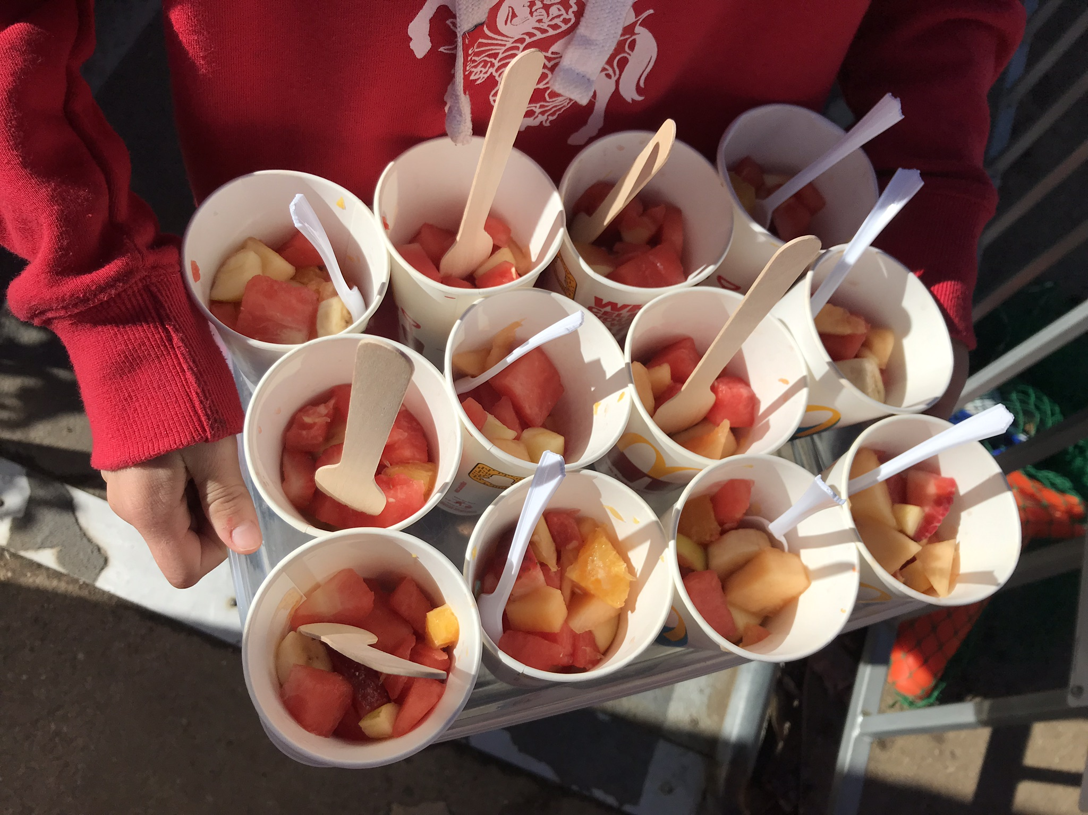

**Canteen this Week** - Friday 26th July: The Grossmith Family

# Last Day Lunch and Activities

We had a great last day of Term 2. We started out by raising $105 for Ronald McDonald House-Orange. The primary students then prepared fruit salad and sausage sandwiches for everybody. We finished off a great term and a fun day with an afternoon at Flipout.