|  |  |  |
| --- | --- | --- |
| Spring Terrace Newsletter  Spring Terrace Public School  A Community of Confident Learners  573 Forest Road, Spring Terrace NSW 2798 T: 02 63654287 Email: springterr-p.school@det.nsw.edu.au | | |
|  | | |
| Term 3 | Week 2 | **Tuesday 30th July 2019** |
|  | | |

|  |
| --- |
| What’s on!!  2019  **Wednesday-Thursday 1st Aug** – Interviews  **Wednesday 7th Aug -** Education Week Activities  **Monday 12th Aug –** School Photos  **Thursday 29th Aug –** Orange Eisteddfod |
| Canteen this Week: **Holmes** Family |

**School Beautification Project**

As was mentioned in last week’s newsletter the group that has taken on beautifying the front of the school have hit the ground running and are ready to start a number of projects.

The first of the plants that have been donated by Bunnings will be picked up this Friday, ready to be planted next Wednesday. In the meantime the students have begun levelling out the front gardens.

We’d love some muscle to help us out with this, if you have a bit of time to spare and can use a shovel please call into school and lend a hand.

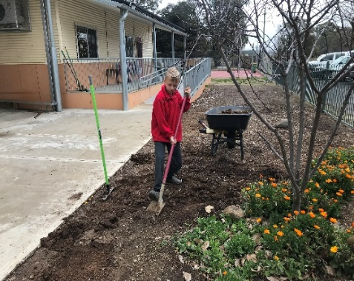So that all students and families can be a part of this project we are going to include some planting and pot painting in our Education Week Activities next Wednesday. Each student with the assistance of their parents will be given a pot to paint and plant to plant. If you can’t attend Education Week we will organise another time for families to take part in this activity.

# 3-Way Interviews

If you haven’t already booked an interview Mr Scott or Miss Toovey will contact you to organise a suitable time.

# School Photos

School Photos will be taken on Monday 12th August at 9:30am. Students need to be in the school winter dress uniform. This includes tartan tunic, pants or skirt and white blouse for girls and grey button up shirt and grey pants for boys. All students need to wear black shoes. Please see a staff member if you are experiencing any problems with acquiring the full school uniform.

**Instructions for ordering as follows:**

* Ordering will be done online this year, on the website where you can choose your preferred background. Full instructions are attached. Payments can be made using Paypal or Credit/Visa Card.
* If you are unable or don’t want to order online, please come into the school office and complete a paper order form, these need to be filled out and money returned before photo day.
* Family/Sibling Photos are available again this year, please call into the office this week for a form/envelope and the order/payment needs to be returned prior to photo day.
* If you have any questions please ring 63423070 or email admin@cspnsw.com.au

**Canteen this Week** - Friday 2nd August: The **Holmes** Family.

Note: A new roster will be attached next week.

**Touch Football**

Well done to Zakk, Riley and Chelsea who played touch football for OSSA White against OSSA Green in the PSSA State Knockout last Wednesday.

Both teams played well but were unfortunately beaten.

**OSSA Spectacular Dance Practise**

The students enjoyed their first dance practise with Bella from Dance Fuse in Orange last Thursday. Dance practice will continue each Thursday for the remainder of the term.

To even up the numbers Year 2 are joining the primary class for dancing. They are also doing maths with the primary class on a Thursday while the infant’s class practises their dance.

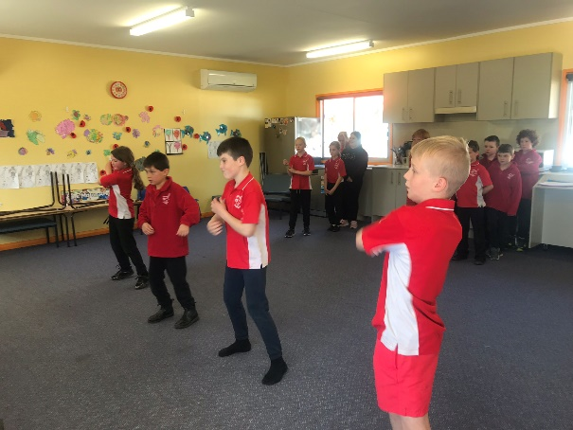

**P&C News**

**Bunnings BBQ Fundraising: Sat 17th August**

The P&C are holding a Bunnings BBQ Fundraiser on Saturday 17th August 2019 to raise money for the beautification of the front gardens of the school. Help will be needed cooking and serving on the day, cutting up onions on the Friday afternoon before, and also drink donations. Please find attached the helper note and return it by this Friday 2nd August.

*Thank you*

*P&C Committee*

**Education Week**

Our Education week Activities will kick off at 10am next Wednesday 7th August. Students will rotate through activities and open classrooms.

# Spring Into School

It is hard to predict the weather this time of year so please dress your child in suitable clothing for the cold weather. Also remember to pack spare clothing in case of accidents.

**\*\*\*\*\* COMMUNITY NEWS \*\*\*\*\***

**Orange Regional Conservation**

**EARLY CHILDHOOD MUSIC** – New Thursday Class  
Thursdays 9:30am.Fun, inspiring and inclusive music classes for kids & babies 0– 5 years. $90 a term per child.

**YOUNG SINGERS** – Group Lesson. Tuesdays 5:30pm – 6:15pm.Learn to sing, read music, build confidence in fun lessons for kids ages 7-10.  Only $200 for Semester 2, plus cost of music book.

**BEGINNER VIOLIN CLASS**  
Tuesdays 3:45pm – 4:30pm  
Learn violin in a fun and inspiring environment using the Suzuki Method with Lisa Stewart (Acacia Quartet) for kids ages 4 – 8. $100 per term.  
  
To enrol visit our [w](https://orangecon.us5.list-manage.com/track/click?u=6d922a426ece867631f983c25&id=00f77049fc&e=5ade632733)[ebsite](https://orangecon.us5.list-manage.com/track/click?u=6d922a426ece867631f983c25&id=f87eb44047&e=5ade632733) or contact ORC Admin on 6361 7974.

**Want some healthy lunch box ideas??**

Cancer Council’s website **healthylunchbox.com.au** is a one-stop-shop for everything families need to know about packing a healthy lunch box.

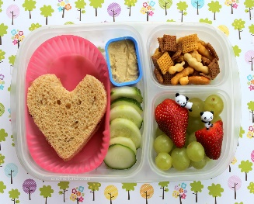Parents will find information on the five food groups, what constitutes a healthy lunch box, sandwich alternatives, sandwich filling ideas, snack ideas, swaps for unhealthy snack foods, recipes and tips. The website features an **interactive healthy lunch box builder where parents can get their kids involved in planning the lunch box and choosing foods they will eat and enjoy.**