|  |  |  |
| --- | --- | --- |
| Spring Terrace Newsletter  Spring Terrace Public School  A Community of Confident Learners  573 Forest Road, Spring Terrace NSW 2798 T: 02 63654287 Email: springterr-p.school@det.nsw.edu.au | | |
|  | | |
| Term 3 | Week 3 | **Tuesday 6th August 2019** |
|  | | |

|  |
| --- |
| What’s on!!  2019  **Wednesday 7th Aug -** Education Week Activities  **Monday 12th Aug –** School Photos  **Tuesday 20th Aug –** Book WeekActivities  **Thursday 29th Aug –** Orange Eisteddfod  **Monday 2ns September –** Life Education |
| Canteen this Week: **Hutabarat** Family |



**Activities**

Our Education Week Activities will kick off at **10am tomorrow,** **Wednesday 7th August**. Students will rotate through activities and open classrooms.

Each student, with the assistance of their parents, will be given a pot to paint and plant a plant in our front garden.

We hope that as many parents, friends and family as possible can come along and join the fun.

*Students need to wear old clothes that are ok to get paint on.*

**Canteen this Week** - Friday 9th August: The **Hutabarat** Family*. Please Note: new roster attached.*

# School Photos – Next Monday 9.15am

School Photos will be taken next Monday 12th August at 9:30am, **if you are transporting your child, please be here by 9.15am.** Students need to be in the school winter dress uniform. **This includes** **tartan tunic, pants or skirt and white blouse for girls** and **grey pants, grey button up shirt and red school jumpers for boys. All students need to wear black shoes.**

**Instructions for ordering as follows:**

* Ordering will be done online this year, on the website where you can choose your preferred background. Full instructions are attached. Payments can be made using Paypal or Credit/Visa Card.
* If you are unable or don’t want to order online, please come into the school office and complete a paper order form, these need to be filled out and money returned **before** photo day.
* Family/Sibling Photos are available again this year, please call into the office this week for a form/envelope and the order/payment needs to be returned **prior to** photo day.
* If you have any questions please ring 63423070 or email admin@cspnsw.com.au

**Absences**

We have had a few phone calls and notes come in but there are still a lot of ‘unjustified absences’ on record. Please remember to contact your child’s teacher, the school office or sign a note if your child is away. We can’t assume your child is sick/still sick, we need confirmation on all absences. If you have a pink slip attached to the newsletter please complete and return or ring the school.

**Book Week**

Book Week is coming in two weeks’ time. Our Book Week activities will take place on Tuesday 20th August.

Students are to come as their favourite book character.

The theme this year is “Reading is Your Secret Power”

**Don’t forget to catch the bus!**

We are doing a great job catching the bus. Keep up the excellent work!

**150 Years Sign**

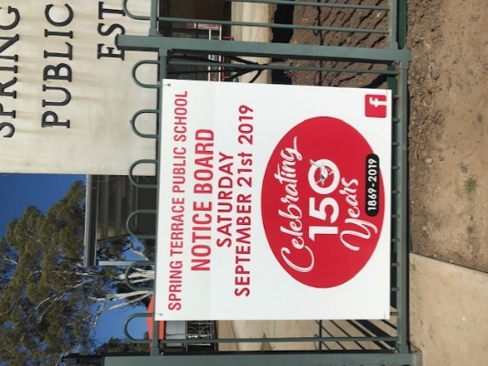Thank you to Christine for the great sign she has made to go next to the front gate. It looks fantastic. You can find her business on face book or the website under ‘Redgum Signwriting and

Graphic Design’.

**Book Club**

Please find attached Issue 5. It is recommended to place your online order by this Friday 9th August.

# 3-Way Interviews

Thank you to all of the parents who made it to the interviews last week. It’s not too late, the teachers would like to share their students’ achievements with every parent. Please contact your child’s teacher to arrange a time to meet if you haven’t already.

**P&C News**

**P&C Meeting**: This Thursday after school to discuss 150th Celebrations.

**P&C AGM:** The AGM will be held within the next 4 weeks, the date and time will be advertised in the newsletter and on the P&C face book page.

**150th Celebrations:** A new Facebook group has been created to start to share and gather information for the 150th celebrations on Saturday 21st September. Please share with any ex-students/families and staff you may know. We will also get some posters/flyers done up soon to share around the community**.**

**Sign:** Thank you to Christine (Joe’s Mum) for the great sign on the front gate.

**Garden Beautification:** Birgette and Christine are organising some artworks for the front garden and are after a post hole digger. If you know someone that canhelp out please contact the school or Birgette (0401 662 099)

**P&C Contact List:** A list of families and contact details is attached to the Newsletter today. Please respect our school community and DO NOT SHARE any of these details. Only use these names and details for school associated events such as after school playdates, swapping rosters, parties and P&C events. Please let the school or Hayley know of any additions/changes to this list.

**Bunnings BBQ Fundraising Sat 17th August:** Help will be needed cooking and serving on the day, cutting up onions on the Friday afternoon before, and also drink donations**. We have only had 5 responses so far, please contact Belinda ASAP!**

*Thank you*

*P&C Committee*

# Spring Into School

Book week is on Tuesday 20th August, children can come dressed as their favourite book character!

**\*\*\*\*\* COMMUNITY NEWS \*\*\*\*\***

**Orange Regional Conservation**

**SING & STRING**  
Fridays 11:00 -11:45am  
Start learning all about music through fun and interactive activities for voice and violin. Perfect for kids aged 4-5! Per Term $95    
  
**Grigoryan Brothers**  
Guitarists, Slava and Leonard Grigoryan are counted amongst the finest musicians of their generation having developed a reputation for enthralling audiences with the energy of their performances and the breadth of their repertoire – embracing genres such as classical, jazz and contemporary music from around the world.

Between them, they have received 3 ARIA awards (Australian Recording Industry Association) and an incredible 24 ARIA Award nominations. As a duo they have recorded 8 albums with the 9th coming out in 2018.  
**Friday 9 August 6pm for 6:30pm**