|  |  |  |
| --- | --- | --- |
| Spring Terrace Newsletter  Spring Terrace Public School  A Community of Confident Learners  573 Forest Road, Spring Terrace NSW 2798 T: 02 63654287 Email: springterr-p.school@det.nsw.edu.au | | |
|  | | |
| Term 3 | Week 5 | **Tuesday 20th August 2019** |
|  | | |

|  |
| --- |
| What’s on!!  2019  **Thursday 29th Aug –** Orange Eisteddfod  **Monday 2nd September –** Life Education Van Visit  **Saturday 21st September** – 150 Years Celebrations |
| Canteen this Week: **Lavers** Family |

**Book Week**

Thank you to all those parents who were able to come along to our Book Week Celebration today. There were some amazing costumes.

# School Photos

The School photo ‘shoot key’ will be activated on **Friday 23rd August.** To place your order go to [www.creativeschoolportraits.com.au](http://www.creativeschoolportraits.com.au) and also complete your order before Friday 6th September, otherwise there will be a $12.95 late fee/postage charge.

If you have any questions please ring 63423070 or email [admin@cspnsw.com.au](mailto:admin@cspnsw.com.au)

**Canteen this Week** - Friday 23rd August: The **Lavers** Family.

**P&C News**

**Bunnings BBQ**: A big thank you to the parents who helped out with the Bunnings BBQ and donated drinks. It was a pleasant, sunny, busy day with close to 60kgs of sausages sold. The count at the end of the day was $1500.00 clear profit.

We can’t leave out **a thank you to** **Belinda and Phil** for their great effort and hard work put into organising the day.

**Garden Beautification:** The garden beautification team met at school on Sunday to continue their great work.

*P&C Committee*

**150th Celebrations – Meeting this Thursday**

**Flyers:** Thank you to Hayley for designing a flyer to be distributed amongst the school community and beyond to advertise our 150 years celebrations. Attached to the newsletter is two copies per family to pass around or put on a community notice board. If you need more copies or an A3 copy, contact Mrs Chapman in the school office.

**Meeting:** There will be a short meeting this Thursday 22ndAugust, after school to touch base and establish where assigned tasks are up to. If you can’t attend the meeting, please contact Bec Robinson or Maxine in the office and leave details of where you are up to, so we are able to move forward to the next stages of organisation.

# Spring Into School

Mrs Louise Ryan will take our Spring Into School class this Friday 23rd August as Ms Hutchison will be away.

Miss Ryan knows the students and their routine. I’m sure they are going to have a fun day.

**Meet Winnie**

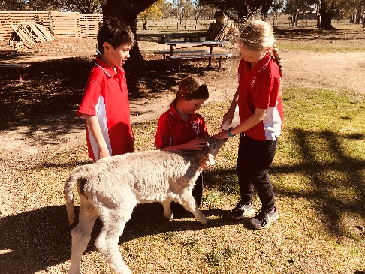Two weeks ago we were introduced to a new member of our school family. She was too cute of a donation to pass up.

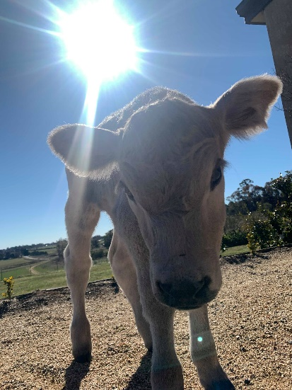

**Library**

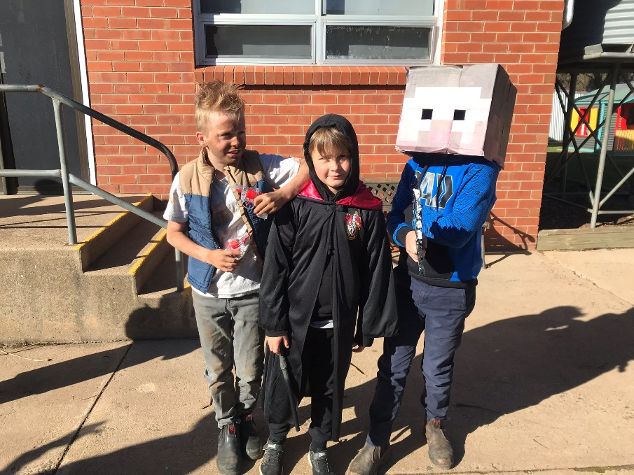

**\*\*\*\*\* COMMUNITY NEWS \*\*\*\*\***

**Orange Regional Conservatorium**

**Chamber Music Series - Concert 3**  
Much Loved Classics Performed by our String Staff. The professional string staff of the Orange Regional Conservatorium present the 3rd concert in the 2019 Chamber Music Series. Vaughan Williams The Lark Ascending, Dvořák Terzetto in C major, Op. 74, Mozart String Quintet No. 3 in G minor, K.516, Lyle Chan The Holidays

Performed by Lisa Stewart (Acacia Quartet), Alina Zborowski, Emily Thorburn, Stefan Duwe (Acacia Quartet), AndrewCallaghan.  
**Friday 13 September 6pm for 6:30pm**  
[TICKETS ON SALE NOW!](https://orangecon.us5.list-manage.com/track/click?u=6d922a426ece867631f983c25&id=51e07c07a2&e=5ade632733)

