|  |  |  |
| --- | --- | --- |
| Spring Terrace Newsletter  Spring Terrace Public School  A Community of Confident Learners  573 Forest Road, Spring Terrace NSW 2798 T: 02 63654287 Email: springterr-p.school@det.nsw.edu.au | | |
|  | | |
| Term 3 | Week 6 | **Tuesday 27th August 2019** |
|  | | |

|  |
| --- |
| What’s on!!  2019  **Thursday 29th Aug –** Orange Eisteddfod  **Monday 2nd September –** Life Education Van Visit  **Saturday 21st September** – 150 Years Celebrations |
| Canteen this Week: **Lawry** Family |

**Orange Eisteddfod**

This Thursday 29th August, all students in K-6 will be heading to the Orange Function Centre to participate in the Orange Eisteddfod. Students have been working hard each day and will be competing in the Small School Choir section with two contrasting songs, “Are We There Yet?” and “Those Magnificent Men In Their Flying Machines”.

Students will be travelling by bus and are required to wear their formal winter uniform, the same as was worn for school photos.

This is a great experience and opportunity for all students, and we look forward to seeing them perform.

# School Photos

School photos are now ready to order online with your ‘shoot key’. To place your order go to [www.creativeschoolportraits.com.au](http://www.creativeschoolportraits.com.au), remember to complete your order before Friday 6th Sept otherwise there will be a $12.95 late fee/postage charge. If you have any questions please ring 63423070 or email [admin@cspnsw.com.au](mailto:admin@cspnsw.com.au)

**Life Education – Next Monday**

The Life Education Mobile Learning Centre along with Happy Healthy Harold will be at our school next Monday 2nd September. Students will attend sessions in three groups, K/2, 3/4 and 5/6. The cost of the visit is $10.00 per student which includes a student workbook and sticker. The permission note is attached, along with a sheet with Harold Merchandise for sale and an option to donate (receipts will be issued for tax deduction). Life Education is a not for profit organisation that relies on community support. **Please return the permission note and orders by this Thursday 29th August.**

**Please note:** *Orders must have the form enclosed with the correct money also your child’s name, the order and the amount of money enclosed - all clearly identified on the front of the envelope.*

**Canteen this Week** - Friday 30th August: The **Lawry** Family.

**150th Celebrations**

Our 150 year celebration is drawing near, please keep this date in mind, Saturday 21st September. We would like as many of our current students and their families here as possible on the day.

Thank you to those parents and community members who have been organising this event, they are doing an amazing job.

**P&C News**

**Garden Beautification:** As part of our garden beautification project the children are going to paint a bird each to go on the fence. If any parents could help cut out these bird shapes from aluminium composite panel using their jigsaw please contact Christine Holmes (Joe’s mum) on 0429 612 622.

This Thursday the students will complete the painting of the poles.

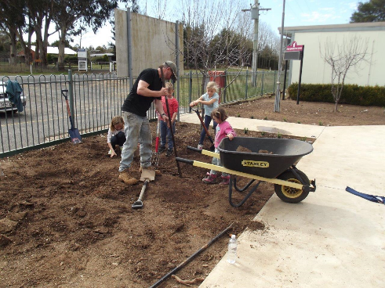

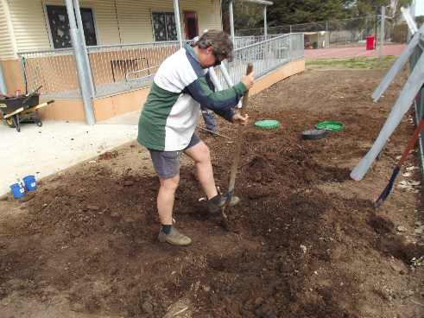

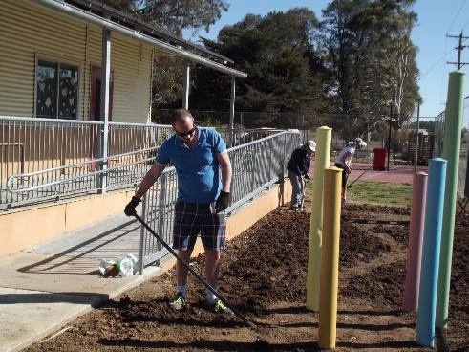

**Spring Into School**

**Invoices:** Please find attached your one-off payment invoices for your child attending our Transition program.

Payments are due in **Week 8** on **Tuesday 10th** **September**, if you have any queries or wish to pay by instalments, please see Mrs Chapman.

**Orientation Days**: Invites will be sent out shortly for your child to attend, in preparation for Kindergarten in 2020.

**\*\*\*\*\* COMMUNITY NEWS \*\*\*\*\***

**Orange Regional Conservatorium**

**Chamber Music Series - Concert 3**

Much Loved Classics Performed by our String Staff .The professional string staff of the Orange Regional Conservatorium present the 3rd concert in the 2019 Chamber Music Series. Featuring Vaughan Williams T*he Lark Ascending*, Dvořák *Terzetto in C major, Op. 74*, Mozart *String Quintet No. 3 in G minor, K.516* and Lyle Chan *The Holidays.* Performed by Lisa Stewart (Acacia Quartet), Alina Zborowski, Emily Thorburn, Stefan Duwe (Acacia Quartet) and Andrew Callaghan. **Friday 13 September 6pm for 6:30pm**  
[TICKETS ON SALE NOW!](https://orangecon.us5.list-manage.com/track/click?u=6d922a426ece867631f983c25&id=ebddad7602&e=5ade632733)

**140th Springside Schoolhouse Birthday Celebration**

**Sunday 22nd September 2019**

**Programme of Events**:

11.00 Welcome to the Schoolhouse

History of the School & Springside locality on display

11.30-

1pm Children’s Events & Events for the young at heart

1-2pm Lunch – Traditional Roast with baked vegetables

2-3pm Thong/gumboot throwing competition

3pm Tug of War

4pm End of Celebration